Yazılım Geliştirme-I Vize Rapor
Software Development-I Midterm Report

Zehra Gül ÖZDEMİR
230229068
Yazılım Mühendisliği
Kocaeli Üniversitesi
Kocaeli, Türkiye
zehragulozdemir@gmail.com

Nur Albina ÖZDİL
220229005
Yazılım Mühendisliği
Kocaeli Üniversitesi
Kocaeli, Türkiye
nurozdil.04@gmail.com

Sevgi Yaren ÖZDEMİR
230229053
Yazılım Mühendisliği
Kocaeli Üniversitesi
Kocaeli, Türkiye
ozdemirsevgiyaren90@gmail.com

INTRODUCTION
This report documents the successful fulfillment of all requirements for the midterm presentation, as outlined in the project guidelines.

Our team has successfully implemented the foundational MERN stack architecture, including a secure backend API for user authentication and a functional, integrated frontend (Interface Draft). All core functionalities required for the midterm, such as database connectivity, secure password encryption, and authentication testing, have been completed and are visually documented below.

Technologıes and selectıon reasons
To meet the project goals, we selected a modern, robust and scalable technology stack, which is known as the MERN (MongoDB, Express.js, React, Node.js) stack. This stack was selected due to it’s cohesive and efficent development workflow, which is centered entirely around JavaScript.

Frontend Stack
    - React (with Vite): We chose React for it’s component based architecture, which allows us to build a reusable and managable UI. Vite was selected for it’s exteremely fast developement server (HMR) and instant updates, which significantly sped up our workflow.

    - React Router DOM: The project requires multiple pages (Login, Register, Dashboard). React Router DOM is the standard library for handling this client-side routing in a Single Page Application (SPA), providing a seamless user experience without full page reloads.

    - Axios & Vite Proxy: Axios simplifies asynchronous HTTP requests (GET, POST, PUT, DELETE) to our backend. The Vite Proxy was essential (Requirement no. 1) to solve the Cross-Origin errors that occur when the frontend (port 5173) tries to call the backend (port 5000) on different ports.
    - Tailwind CSS: To rapidly build the “Interface Draft” (Req. 6), we chose Tailwind. It’s utility-firts approach allowed us to design a modern, responsive interface directly within our JSX, ensuring a consistent look and feel.

  - Backend Stack
    - Node.js & Express.js: Node.js was chosen for it’s non-blocking I/O, making our API fast. Express.js provides a minimal and flexible framework, allowing us to build our RESTful API endpoints (/api/auth, api/task etc.) quickly.

    - Mongoose: Mongoose was selected to manage the relationship between our data and MongoDB. It provides a straightforward, schema-based solution for modeling out “users” and “tasks” collections and includes built-in type casting and validation.

  - Database
    - MongoDB Atlas: As a core part of the MERN stack, MongoDB’s flexible, JSON-like document model was a perfect fit for our “users” collection. We chose the cloud-hosted Atlas platform for it’s reliability, scalability and ease of setup for a remote team.

Security and Encryption
    - bcrypt.js: To fullfill the critical “Encryption” requirement (Req. 5), we chose bcrypt.js, the industry standard, to hash and salt user passwords before they are ever stored in our database.

    - JSON Web Tokens (JWT): JWT was chosen to manage secure user sessions. Upon successful login, the API issues a token, which the frontend uses to authorize requests and protect the Dashboard page from unauthorized access.

VISUAL EVIDENCE OF REQUIREMENT FULLFILLMENT
  - Frontend + Backend Integration (Req. 7.2)
The frontend and backend are fully integrated (Req. 1). A successful login (api/auth/login) results in the backend sending a JWT token, which the frontend (React) stores in localStorage to manage the user's session and redirect them to the protected Dashboard.
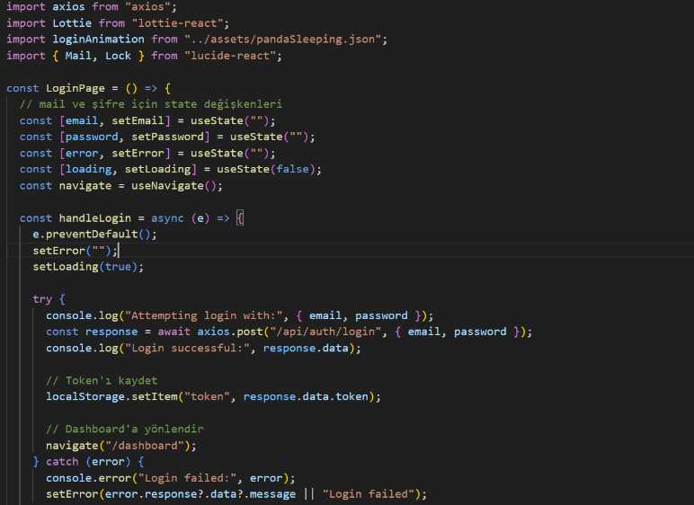
Figure 1: Frontend axios request from Login page to send the data to backend and receive the JWT.

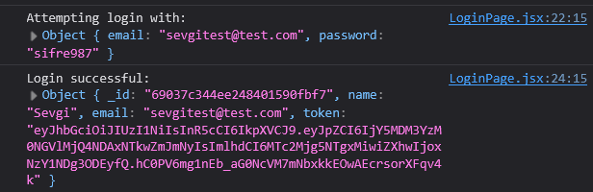Figure. 2: Browser developer tools showing successful user authentication and token response.

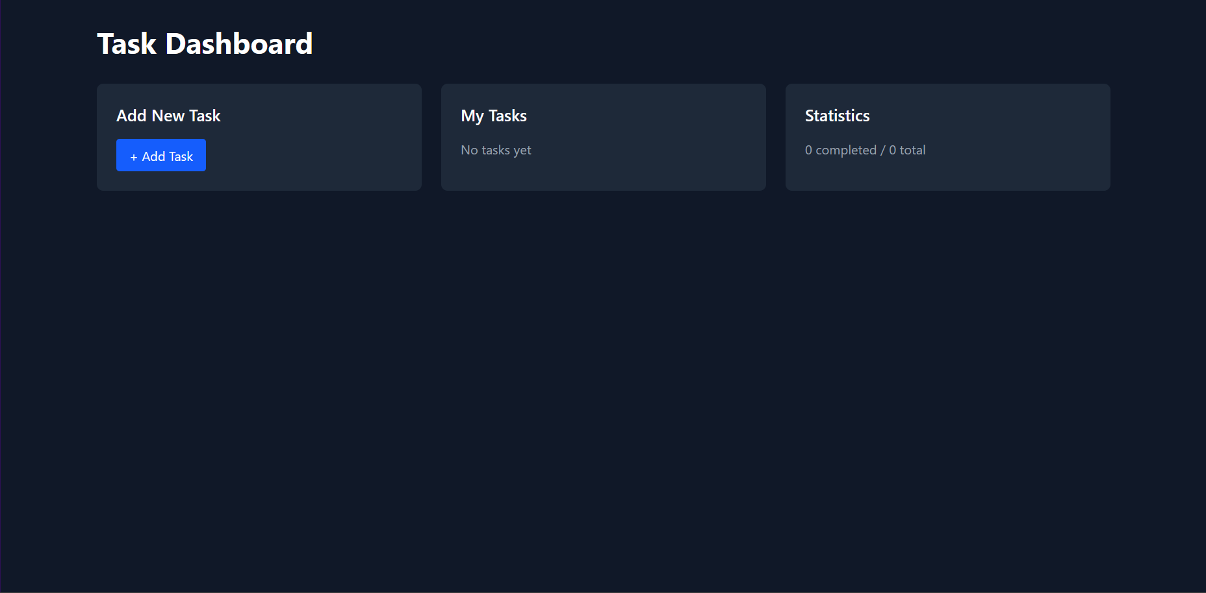Figure. 3: User is redirected to the protected Dashboard page upon successful login.

Active Database Connection (Req. 7.3)
The backend server terminal log shows a successful connection to our MongoDB Atlas cluster upon starting the application.
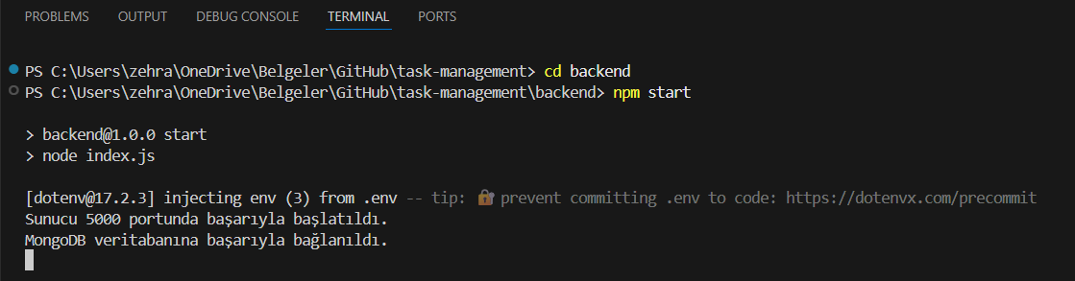Figure 4: VS Code terminal output showing successful connection to MongoDB Atlas.

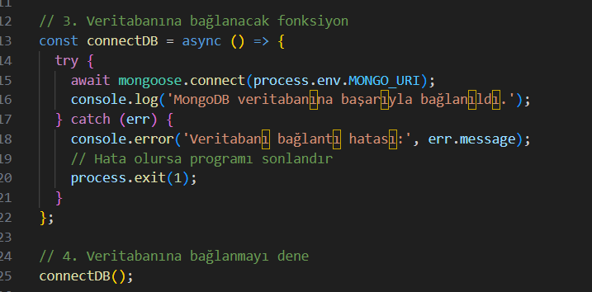Figure 5: Code snippet for database connection using mongoose.

Invalid Login Outcome (Req. 7.6)
The system securely handles invalid login attempts (Requirement #4). When a user enters an incorrect password, the backend API correctly returns a 401 error, which the frontend catches and displays to the user.

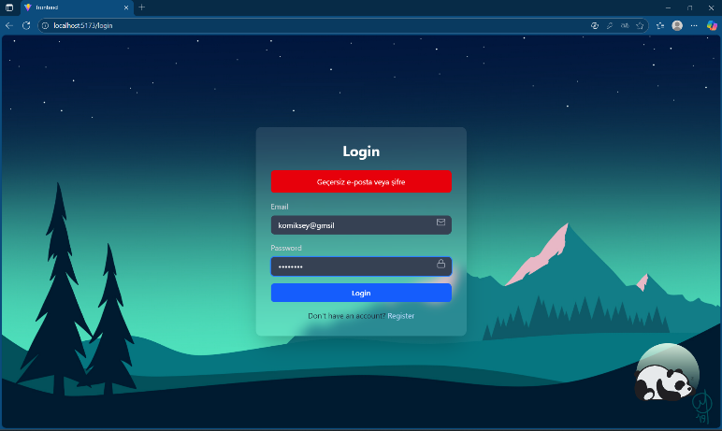
Figure 6: The React Login UI displaying an "Invalid email or password" error message after a failed attempt.
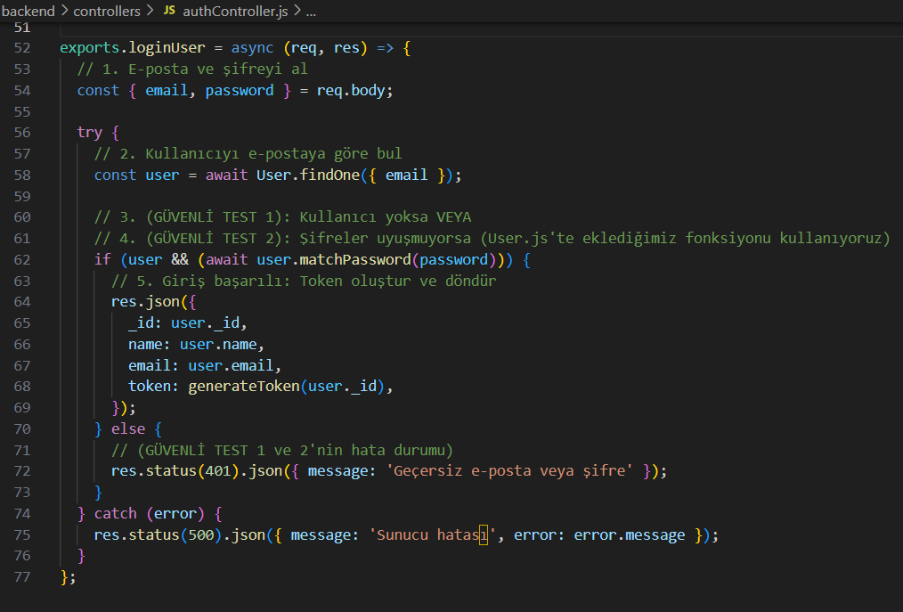Figure 7: The backend controller logic for handling a login attempt.

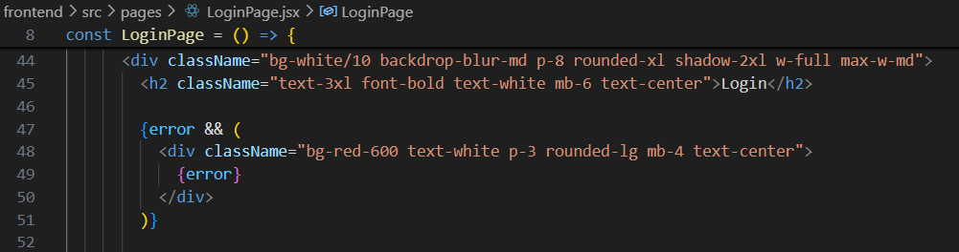Figure 8: Frontend code for showing a warning in red after catching an error.
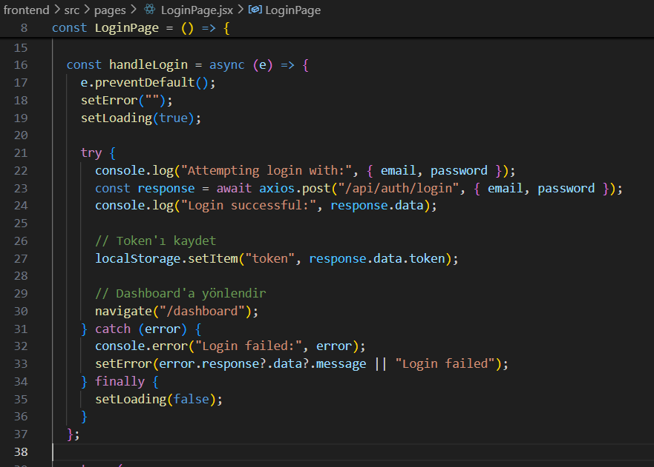Figure 9: The frontend logic for catching a login error

Interface Draft (Req. 7.4)
The complete interface draft for the midterm scope (Req. 6) is functional and styled. This includes dedicated React components for the Login page, Register page, and the protected Dashboard page. Navigation between these pages is managed by react-router-dom, and the UI/UX has been styled using Tailwind CSS for a modern, responsive design.

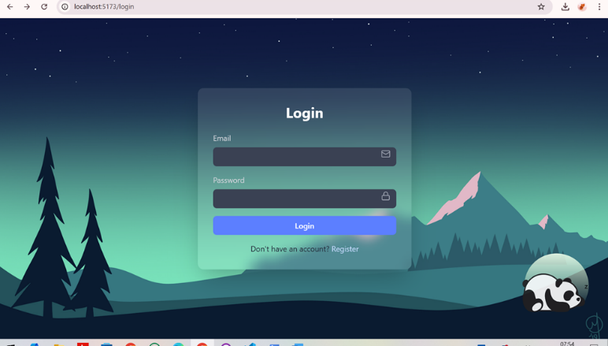Figure 10: The final design of the Login page interface (/login).
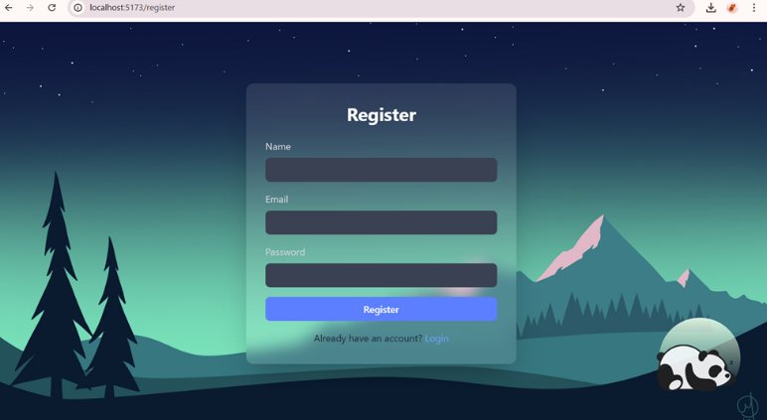Figure 11: The final design of the Register page interface (/register).
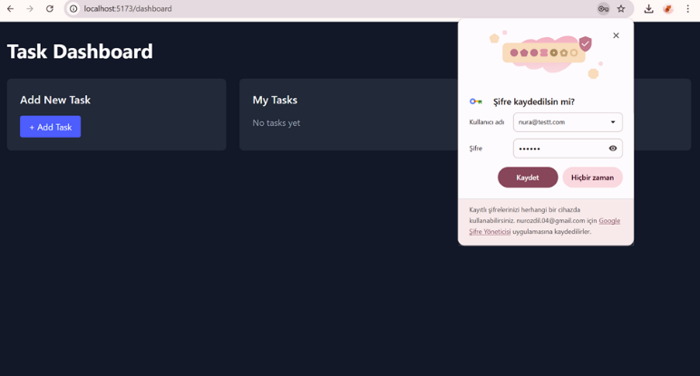Figure 12: The protected Dashboard page (/), visible only to authenticated users.

Storing Password After Encryption (Req. 7.5)
To ensure security and meet Requirement #5, all user passwords are processed by bcryptjs before being saved. Our Mongoose User model implements a pre('save') hook, which automatically intercepts the plain-text password, generates a secure hash (using a salt), and stores only this non-reversible hash in the MongoDB database. The plain-text password is never stored.

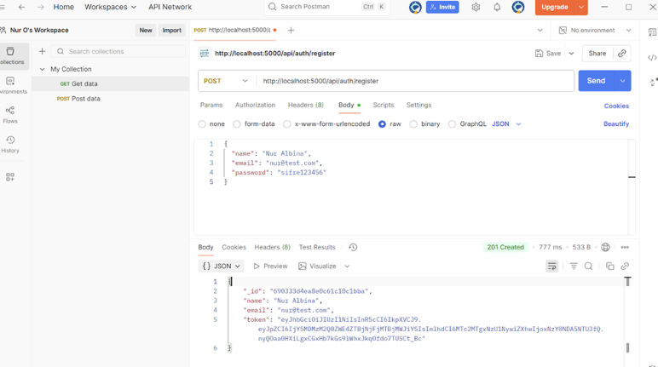
Figure 13: MongoDB Compass view of the 'users' collection. The 'password' field is clearly a non-readable hash.

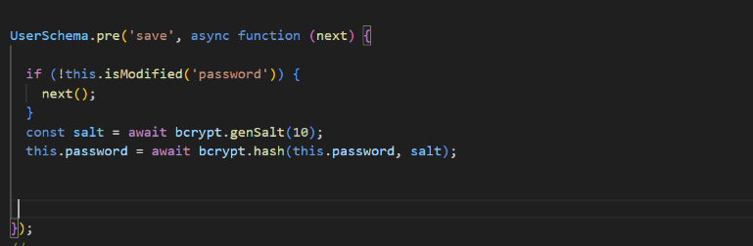
Figure 14: Code for the password encryption requirement.

Kaynaklar
- https://mongoosejs.com/docs/guide.html
- https://www.w3schools.com/react/react_router.asp
- https://www.jwt.io/introduction#what-is-json-web-token
- https://blog.logrocket.com/password-hashing-node-js-bcrypt/
- https://tailwindcss.com/docs/styling-with-utility-classes
- https://expressjs.com/en/guide/routing.html
- Subramanian, V., “Pro MERN Stack: Full Stack Web App Development with Mongo, Express, React, and Node,” 2nd ed., Apress (Springer), Berkeley, CA, 2019, ISBN-13 (electronic) 978-1-4842-4391-6, DOI: 10.1007/978-1-4842-4391-6.
- Chauhan, A., “A Review on Various Aspects of MongoDB Databases,” International Journal of Engineering Research & Technology (IJERT), vol. 8, no. 05, pp. 90-92, May 2019.
- Bawane, M., Gawande, I., Joshi, V., Nikam, R., & Bachwani, S. A., “A Review on Technologies used in MERN stack,” International Journal for Research in Applied Science & Engineering Technology (IJRASET), vol. 10, no. 1, pp. 479–487, Jan. 2022.
- Kulshreshta, A., Rawat, N., Saxena, K. and Agrawal, P., ``Web based Accounting Integrated Management System (AIMS) over Cloud using MEAN Stack,'' Proc. Int. Conf. on Issues and Challenges in Intelligent Computing Techniques (ICICT), 2019

